AIX IPSEC limitation affecting the Unisys AIX Stealth Agent

Problem statement:
An AIX endpoint cannot establish multiple Stealth-managed IPsec tunnels to the same IP address on a remote endpoint.

This is an example illustration of the “problem” configuration.

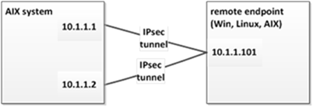

The issue results from a limitation in AIX IPsec configurability – cannot have multiple IPsec tunnels, each using a unique IKE authentication pre-shared key, to the same remote endpoint address.

The issue applies strictly to multiple IPsec tunnels in a configuration such as above. Configurations / traffic scenarios such as the examples pictured below are supported. In other words, all other “multiple IP address” endpoint feature content operates properly (Stealth packet filtering / “firewalling” capability, etc.).
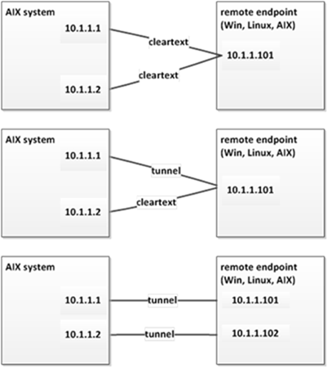

As a first step to establish an IPsec tunnel between two systems, IPsec software on each system establish a communication channel, and a first step of establishing this channel is authenticating the peer system. This IPsec software on AIX systems is IBM’s native IKE daemon.

In a Stealth environment, IKE peer authentication is done using a “pre-shared key” (PSK) – a hexadecimal string value that both IKE peers have been run-time configured with by Stealth endpoint software. Stealth uses a unique, generated-just-in-time PSK for each Stealth (IPsec) tunnel.

The issue we’ve identified is a limitation in how a tunnel’s PSK value is identified / configured on AIX:
· A tunnel’s PSK value is identified using the IP address of the remote system. Ex: In the below diagram, the AIX system on the left would configure a PSK with an ID of “10.1.1.101”.
· Two tunnels cannot be configured using the same PSK identifier

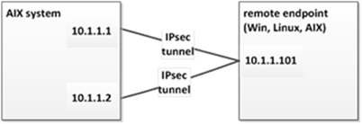

So, for the above example, on the (left) AIX system:
· Stealth software can successfully run-time configure AIX with a PSK for an IPsec 10.1.1.1 – 10.1.1.101 tunnel, and the tunnel is successfully established
· Later, when Stealth endpoint software attempts to configure AIX with a different PSK value for the 10.1.1.2 – 10.1.1.101 tunnel, AIX IKE software returns a “PSK remote id already exists” error, and the tunnel cannot be established.

FWIW - IKE software that Stealth uses on Windows and Linux systems do not have such a restriction.

Mark Sullivan | Support Engineer | Technology | U.S. Engineering Resources & Operations | Malvern Software Development
Unisys | Office 610-648-4331 | Mark.Sullivan@Unisys.com
2476 Swedesford Road, Malvern, PA 19355

