Screen Shots

1. After writing a SQL statement moving the cursor into the next line and then right click the mouse and then select Execute Current Text or press Alt + S comes up with error.

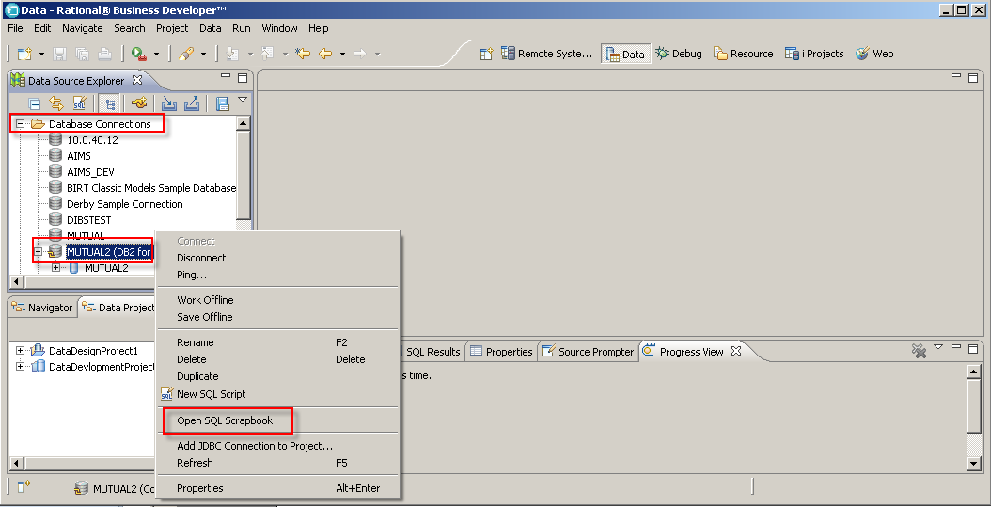

Type SQL Select statement and then Move the curser to NEXT LINE and press ALT + S or right click mouse and select Execute Current Text

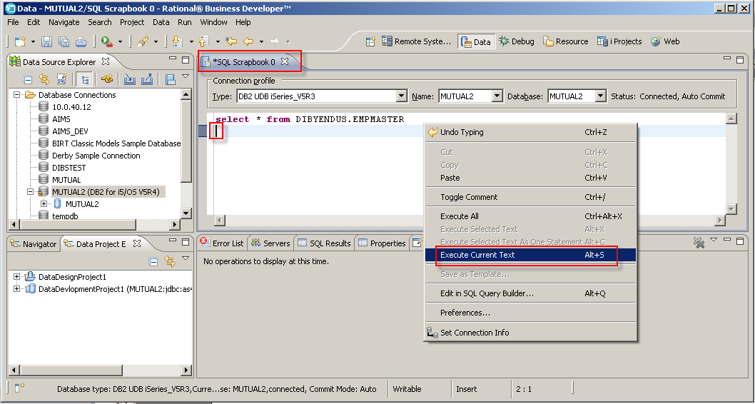

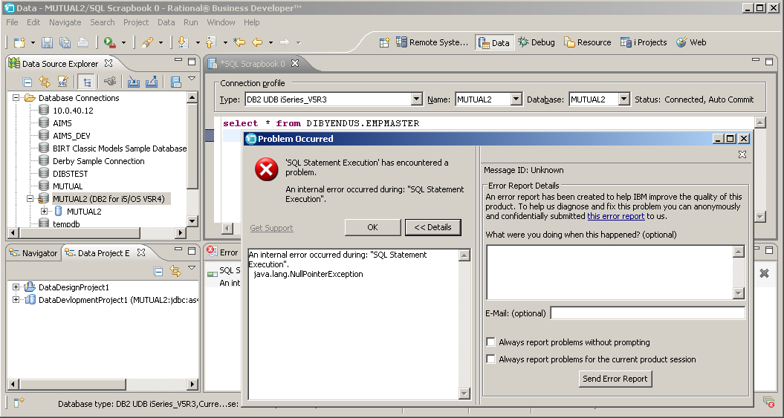

3. In the SQL Scrapbook in SQL SELECT Statement after WHERE clause by pressing Ctrl+Spacebar inelegancy does not work, it do not brings the column names whereas from the SQL Script it works fine. From SQL Script in a SQL SELECT statement after JOIN schema name/library name and then typing DOT (.) brings all the table/file names whereas it doesn’t bring back in the SQL Scrapbook.

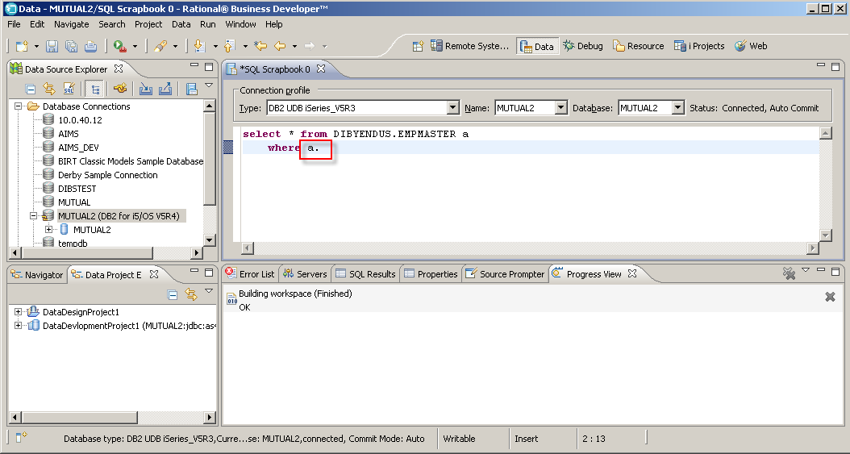

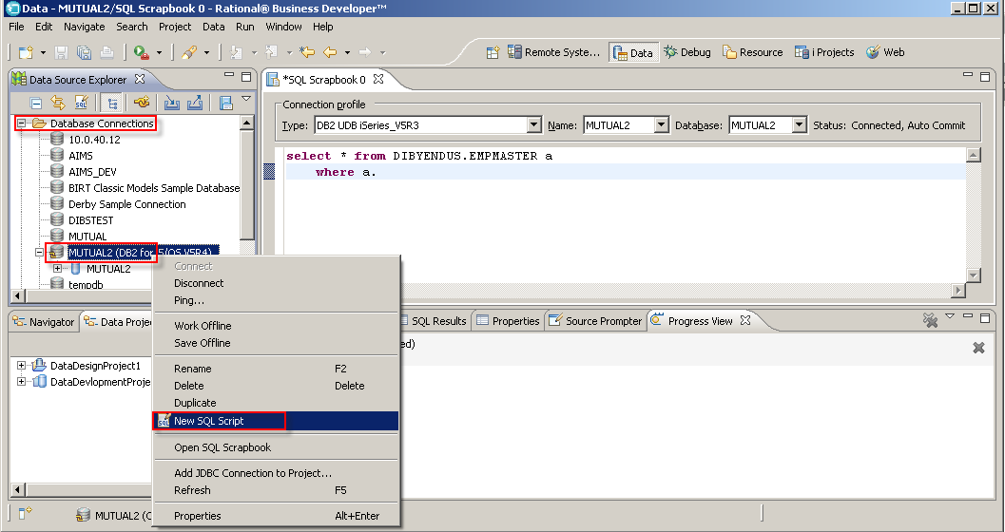

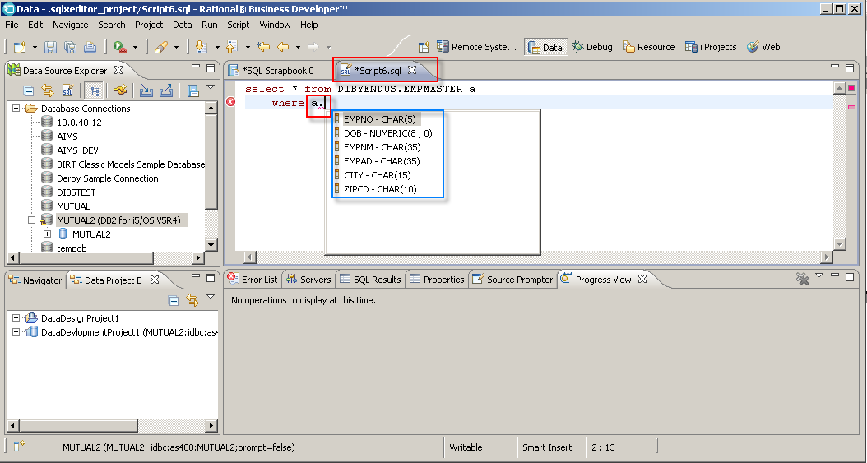

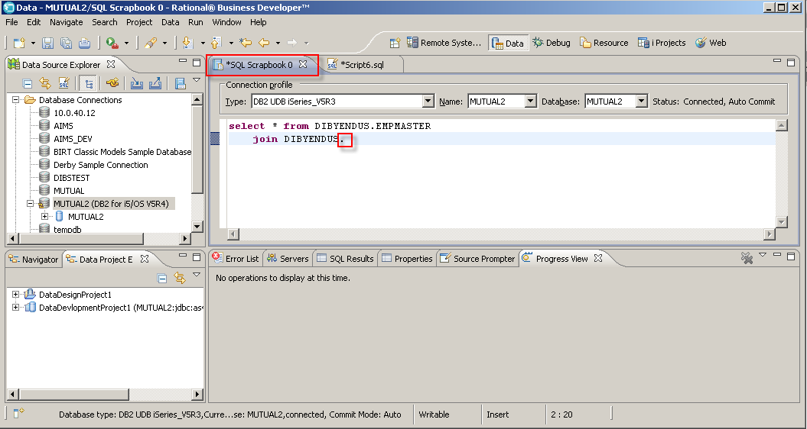

Typed schema name and imeeditaly after typing DOT (.) brings all the table belongs to that schema or type first few characters of the table name and then press Ctrl + Spacebar will bring the subset view of the tables.

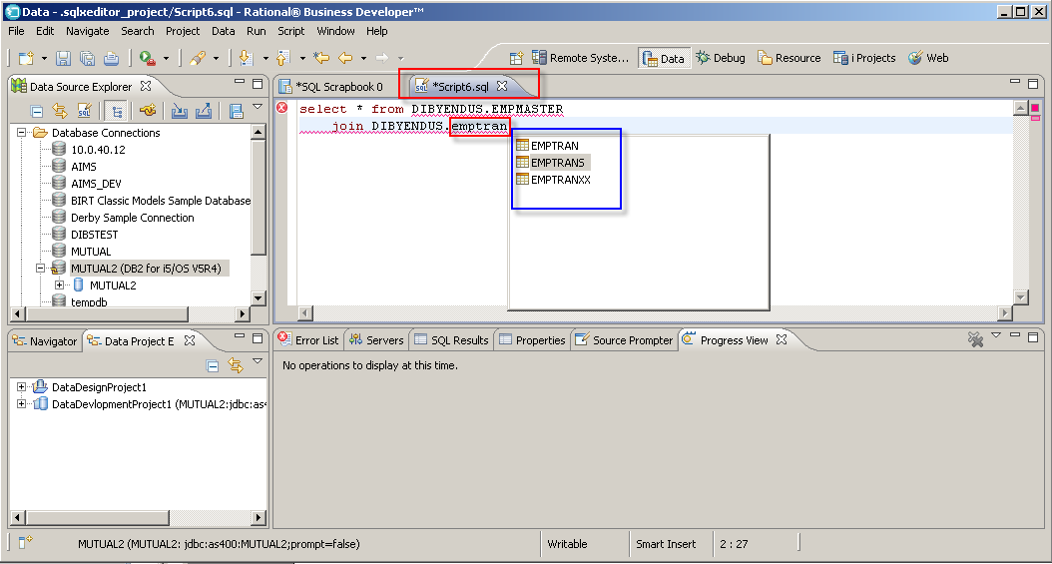

4. In a JOIN SQL statement although defining the table alias name and then ON clause alias name DOT (.) does not brings the list of columns for both in SQL Scrapbook and SQL Script. This feature will be really helpful as we don’t have to type the column names for a JOIN SQL statement.

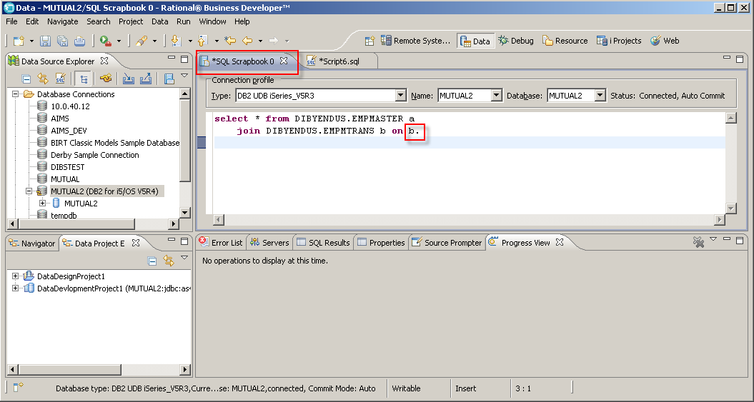

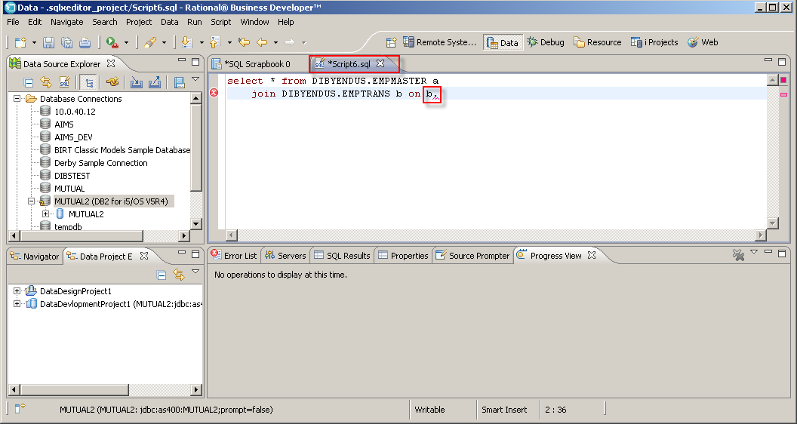

5. In the Data Perspective after connecting to a iSeries DB2 database then right click the mouse to the connection then select Properties and then select the Driver Properties option then change the Default Schema value with some valid values (existing schema name) and the press OK button. Then it ask for confirmation for reconnecting the server but on pressing the Yes button does not reconnect to the server again.

