Example 1: This is what the user sent. In the Auto-Entry drop down list any data in the editable fields appear in the list when one or more of the fields is updated.
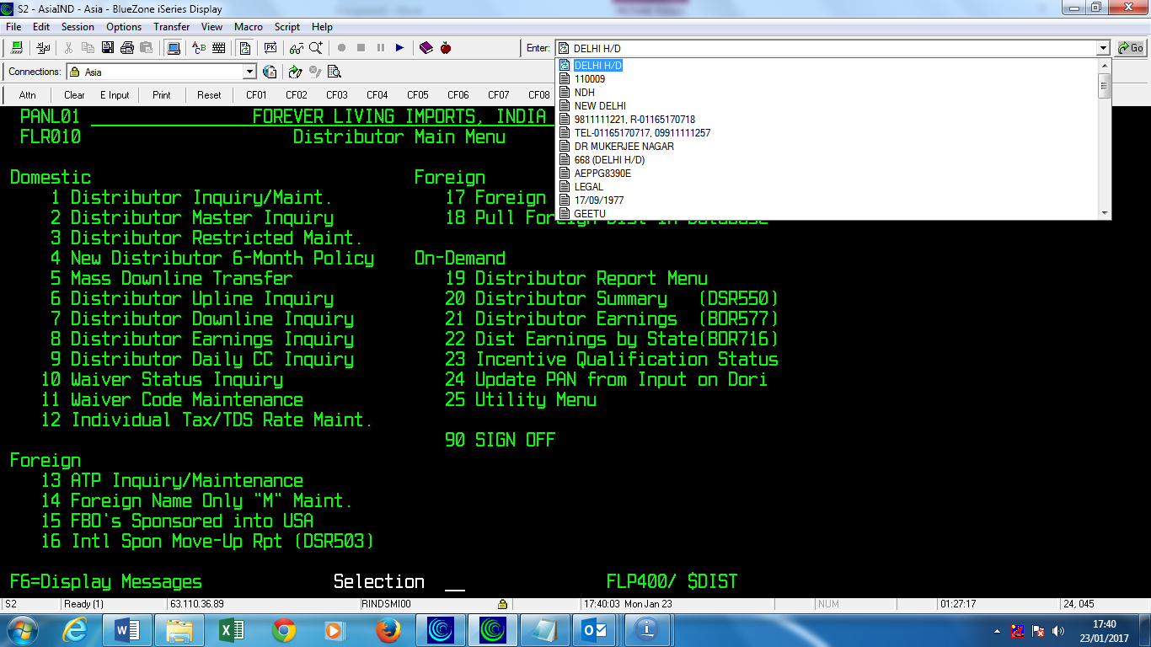

Example 2: I contacted the user to see how I can recreate what they did using their menu instead of command line (see example 3 below).
FLPBRL – appeared in the drop down list when I signed in and hit enter
telnet asia – appeared in the list when I did a telnet and hit enter
1 – appeared when I mouse clicked on #1 on previous screen
D and 910 and 000000011 – appeared on the screen when I typed 000000011 and hit enter. All data in editable fields appear in the list if 1 or more editable fields is updated. On this screen editable fields are Sort Selection, Beginning Select and Opt column.
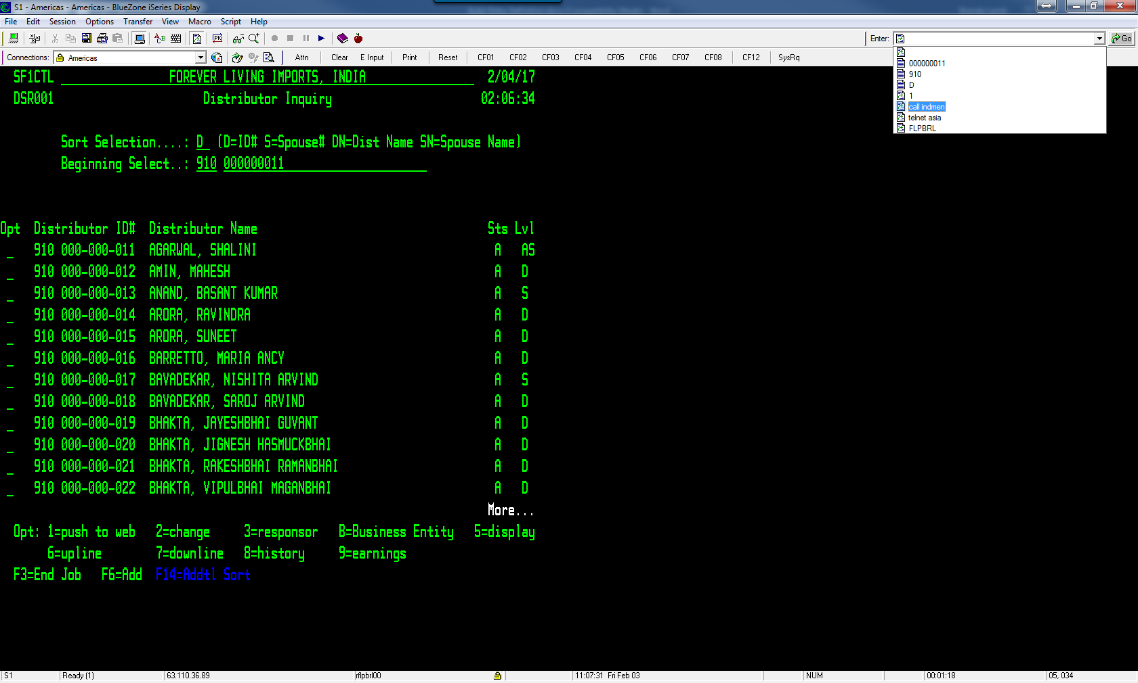

Example 3: This is another example where I didn’t go through users menu but rather command line.
- FLPBRL – appeared in the Auto-Entry drop down list when I signed in and hit enter
- dspusrprf - appeared in the list when I typed dspusrprf on the command line and then did F4=Prompt
- *BASIC and *print – appeared in the list when I filled in flpbrl, *print in the editable fields and hit enter
- DSPUSRPRF USRPRF(FLPBRL) OUTPUT(*PRINT) - appeared in the list when I did F9 to bring up the command and then hit enter
