iNav has the hover over statement text pop up.
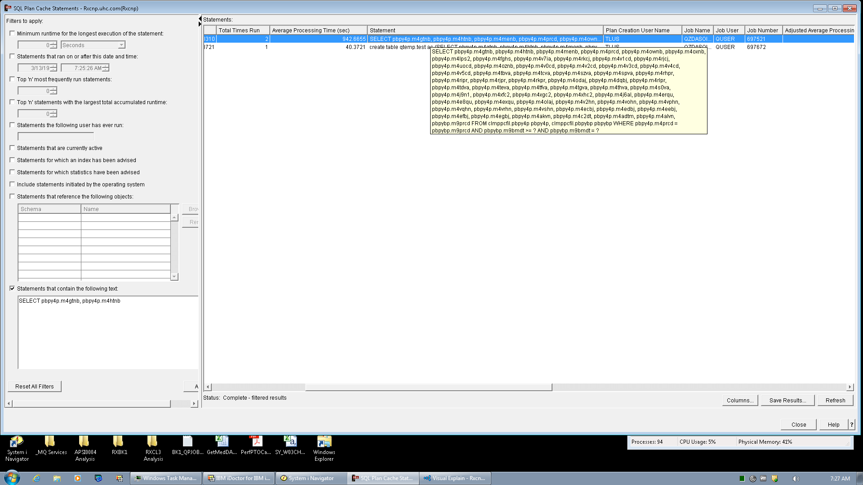

ACS 1.1.8.1 (for the exact same window/statement) does not have the hover over statement text bubble.
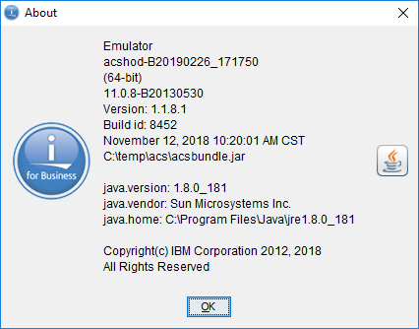
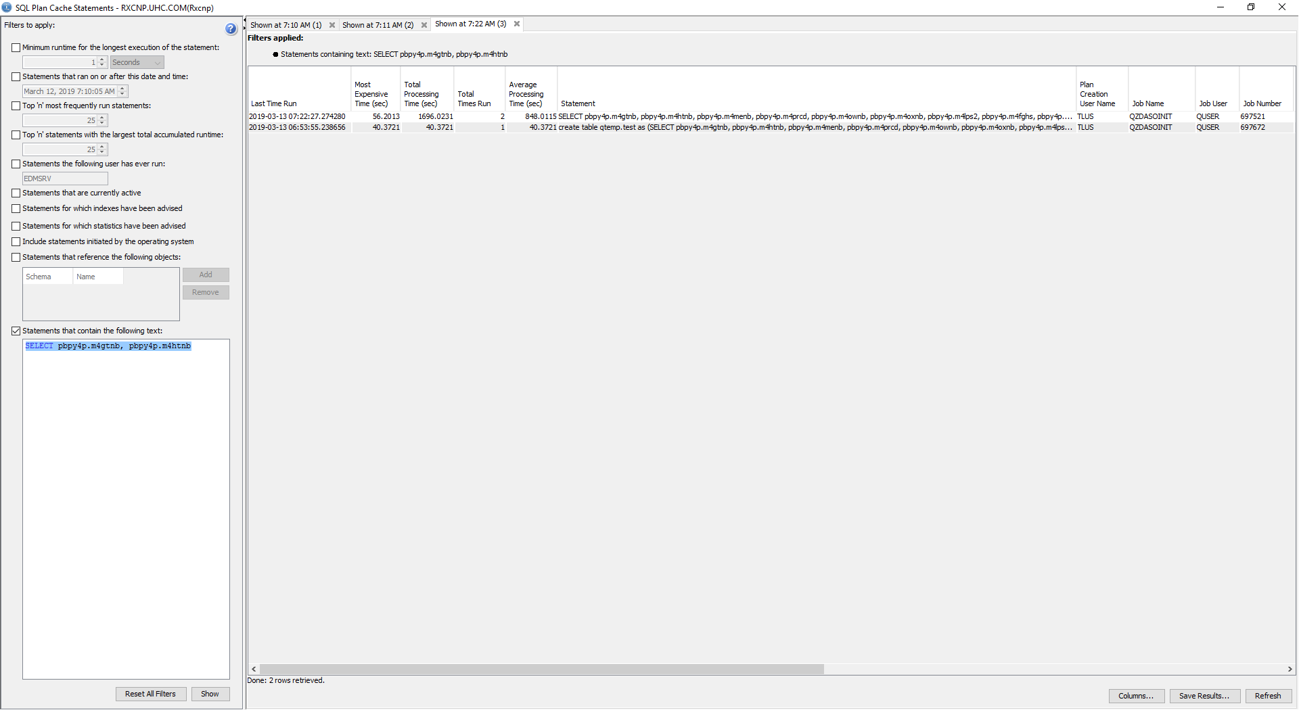

I would like to have the pop up full text bubble/window added.

