Opening any XML editor in RDi
This process is limited to selecting an editor. It does not address the question of verifiying XML rules.
I right-clicked on the XML file and got these options.
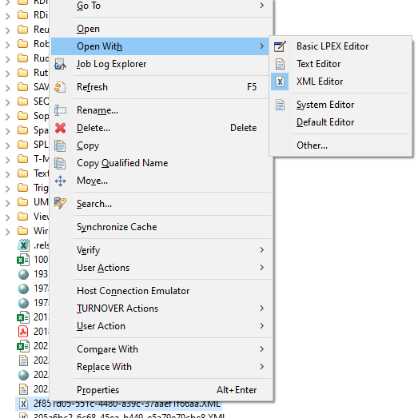
I clicked on Other… and got this window.
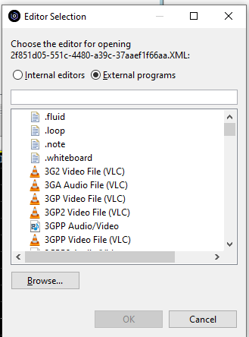
I clicked on Browse… and File Explorer opened – I dug through it until I found the editor I wanted.
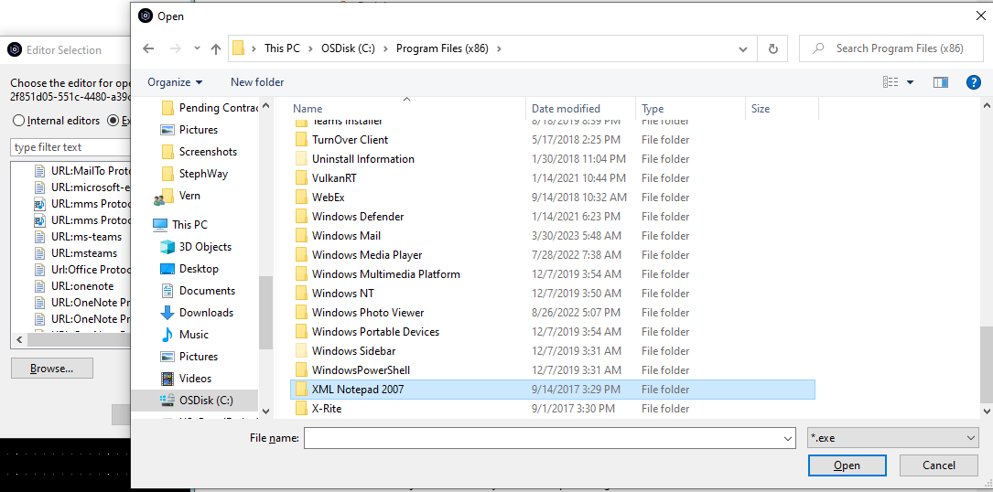
I clicked Open and found the executable.
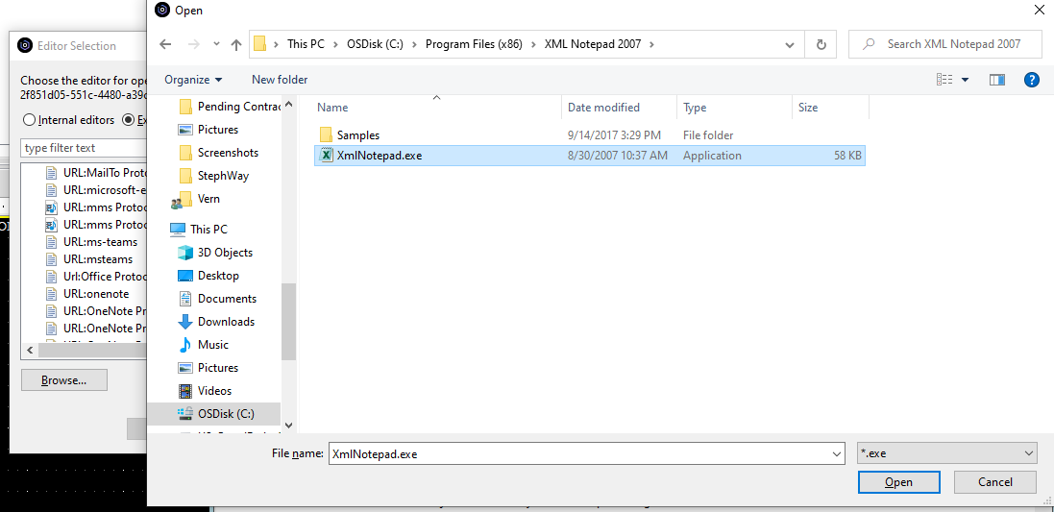
I clicked Open again, and that editor was added.
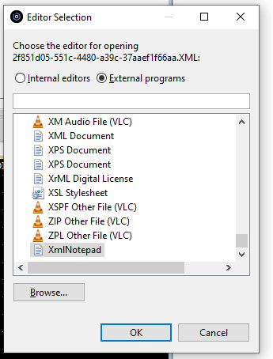
I clicked OK, and the editor opened outside of RDi.
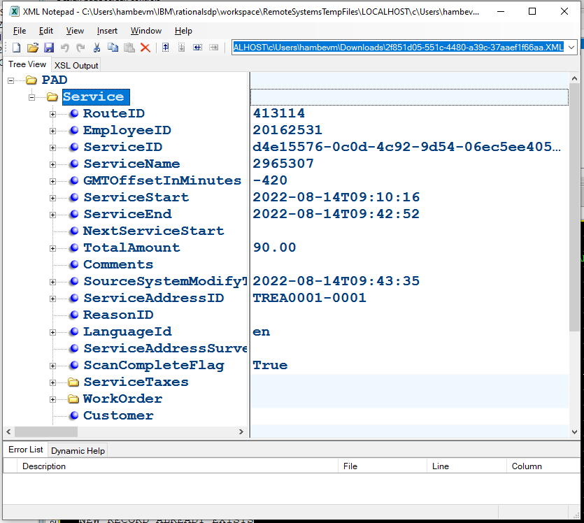
I had to do this twice – I did not explictly select XmlNotepad the first time, I did the 2nd time.

